**Chapter 09 - Optimizing our App**

**❓ 1) When and why do we need lazy()?**

**🔹 Step 1: Define**

* lazy() is a **React function** (React.lazy) that lets us **dynamically load components** only when they are needed.
* This is also called **code-splitting** or **lazy loading**.

**🔹 Step 2: Why it exists**

* In large apps, bundling everything into one JavaScript file increases initial load time.
* lazy() helps by **splitting code into smaller chunks** and loading components only when required.

**🔹 Step 3: Where it’s used**

* Typically used in **routing** (load a page/component only when the user navigates to it).

**🔹 Answer**

We use lazy() to **optimize performance** by avoiding loading unnecessary code at startup.

Example:

**❓ 2) What is Suspense?**

**🔹 Step 1: Define**

* Suspense is a **React component** used to **show a fallback UI (like a loader)** while a component is being lazily loaded.

**🔹 Step 2: Why it exists**

* Without Suspense, React wouldn’t know what to render while waiting for the lazy component.

**🔹 Step 3: Where it’s used**

* Always used with React.lazy() or with data-fetching libraries (like React 18 server components).

**🔹 Answer**

Suspense provides a **better user experience** by showing a loading indicator until the component is ready.

Example:

**❓ 3) Why we got this error:**

**"A component was suspended while responding to synchronous input..."**

✅ Final Interview-style Answer:

This error happens because React tried to load a lazy component (suspend) while handling a synchronous user input like typing.

That causes the UI to suddenly replace the input with a fallback, which is bad UX.

In React 18, the fix is to wrap such updates inside startTransition, so React knows it’s a urgent update and won’t block urgent updates like typing.

Suspense ensures a smooth fallback UI while the component is still loading.

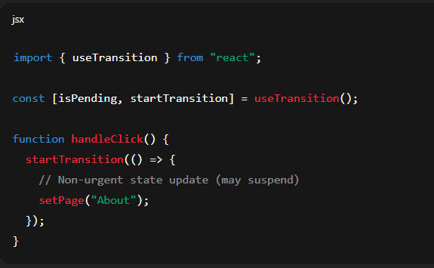

**❓ 4) Advantages and Disadvantages of code-splitting with lazy()**

**🔹 Advantages**

* 🚀 Faster initial load (only necessary code loads first).
* 📦 Smaller bundle size.
* 🎯 Better performance for large apps.

**🔹 Disadvantages**

* ⏳ Extra loading time for lazily loaded components.
* ⚠️ Possible flash of “Loading...” if network is slow.
* 🔧 Slightly more complex code (must wrap with Suspense).

**❓ 5) When do we and why do we need Suspense?**

**🔹 Step 1: Define**

* Suspense is React’s way of **handling asynchronous rendering gracefully**.

**🔹 Step 2: Why it exists**

* It avoids showing a blank screen while waiting for components/data to load.

**🔹 Step 3: Where it’s used**

* When using lazy() for code-splitting.
* With **React 18 concurrent features** (like data-fetching frameworks).

**🔹 Answer**

We need Suspense whenever a component **may not be ready immediately** (due to lazy loading or async data). It ensures the user always sees a fallback UI instead of a broken screen.

✅ **Interview-style summary**:

"lazy() is used for code-splitting by dynamically importing components, which reduces initial bundle size. Since these components don’t load instantly, React provides Suspense to show fallback UI while waiting. If a component suspends during a synchronous user action, React suggests wrapping updates in startTransition to avoid blocking urgent updates. Code-splitting improves performance but adds complexity and introduces potential loading delays. Suspense is required whenever a component might suspend to keep the UI responsive."